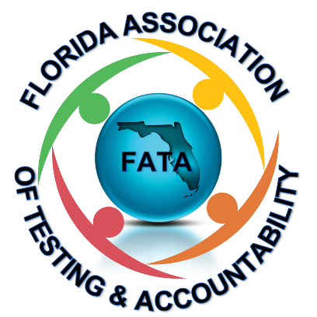
FATA
Annual Meeting
September 8, 2020 10:00-12:00

Welcome Neyda Francis President
Roll Call Charlene Sozio Secretary
Financial Report Pete Zsiga Treasurer
New Board Introduction Neyda Francis President
FATA Updates Barrington Maxwell President

Join us on Facebook: https://www.facebook.com/groups/1811847289032283
FATA Website: https://www.floridatestadmin.com/
Platinum Sponsors
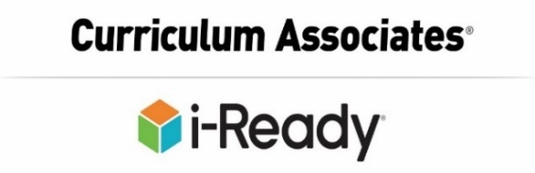
Silver Sponsors

Bronze Sponsors

