FATA Meeting Minutes
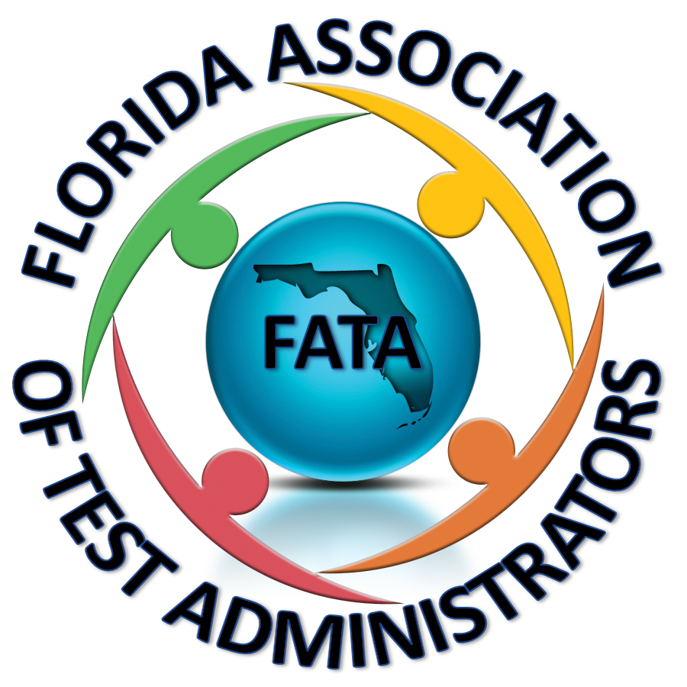
October 5, 2016
8:30-9:30 Lake Mary Marriott

- Paula welcomed everyone and we did introductions. She said that the survey process is working well. She would like to have districts continue to send her questions and then maybe once a month she will send out a survey with the questions compiled and whoever wants to answer can. She will keep it private if you don’t want your district identified.
- FATA Annual Meeting—we would like to hold an independent meeting the day before the state assessment meeting begins. We could have speakers, breakout sessions, etc. Perhaps the first year we could do a half day and begin at 1:00 so people have time to travel. We would have a registration fee attached to offset the cost. We would like to put a committee together to work on this—Paula will send an email out to ask for volunteers.
- FAMIS—June 27-29 in Daytona Beach this year. We would like to hold a FATA meeting for those that are attending FAMIS.
- FERA—Nov. 16-18 in Lakeland this year. We would like to pair up with this organization to hold a joint meeting with them next year. We are thinking of approaching their board to work with them and either be a breakout session within their meeting or have an independent meeting at their meeting. Donna Buckner from Polk is their president.
- National Conference on Student Assessment—Cyndy and Barrington from Orange went last year and it was very good. It is the same week as FAMIS this year and it is being held in Texas.
- FLVS—FLEX is supporting the FT side and they are providing one contact to work with the districts to help streamline the communication. They are working on a ShareFile site so that districts have access to student lists and test tickets at all times.
- AP Credit w/out Course
  - Does your district plan to pay for students who can’t afford it?
- PERT Policy—it would be nice to have some consistency across districts. Some feel it is being watered down if it is given over and over without remediation.
- EOC 30%
  - There is a lot of inconsistency, some districts give an “I” until the test is taken while others give the student an F to “close out” the grade.
  - There is also inconsistency with how the grade is assigned to the achievement level/scale score. Because districts use different ways to assign the grade it opens the door for parents to complain.
- Pre ID File—New ESE/504 field is causing difficulty for some districts because some SISs don’t keep track of if ESE/504 students have accommodations so it has to be either all yes or all no and schools would have to go in and adjust as needed. We feel it should be a data survey element not through trusting districts/schools to report the information if DOE is collecting this information.
- Non-College Reportable ACT Version Used as a Concordant Score—this administration gives extended time to all students so some districts use it as a concordant for only ESE and ELL students, however there is nothing to say that it can’t be used for all of the students. This gives an unfair advantage to the regular ed students.
- Discussion was had about adults coming back to take tests to meet their graduation requirements. Districts will allow students who did not graduate/attend a school in their district to test with them as an adult.
- Out of State Alg. 1 EOC chart needs to be updated.
- Learning Gains Calculation—Sam Whitten has worked with the data in his district and found the following:
  - With regards to learning gains he found that it is unattainable for the lower students to stay on track with the state’s growth requirement. This calculation punishes low socioeconomic schools, they don’t have much chance of doing better with accountability.
  - The state requiring math level 3, 4 and 5 to take Alg. 1 is not fair. Not all students should be forced to take Alg. 1, some are not ready, especially the level low level 3. It gets worse when level 1 and 2 Alg. EOC students are forced to go into Geometry, the pass rate gets even worse. Liberal Arts math should be a viable option for students who aren’t ready for Geometry or Alg. 2. He suggests Alg. 1A for 9th, Alg. 1B for 10th, Liberal Arts in 11th and Geometry in 12th. This also leaves no learning gains for 10th grade.
    - One district had 8th graders take 8th grade math and Alg. 1 and they said the scores were good.
- Test administration is a struggle, we would like to share ideas on scheduling so that we can maximize learning during testing season.
- ELA Writing—90 minute versus 120, Paula has made a script and will share with everyone.
- Meeting adjourned at 9:57

