FATA Meeting Minutes
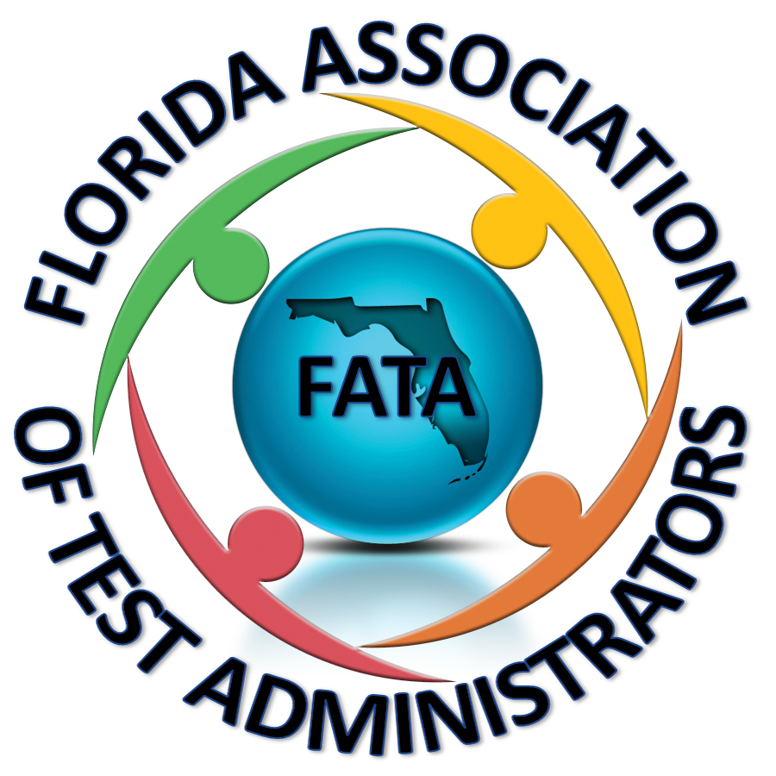
FAMIS Daytona Hilton 6/27/17

- Debrief Update:
  - HB 7069
    - Grade 3 ELA will remain on paper for 2017-2018.
    - In 2018-2019 all subjects for grades 3-6 will be on paper.
      - How are districts going to handle managing paper tests—storage, delivery, pickup, etc.
    - Paper item types are different on paper than computer, how will they keep the rigor?
      - DOE is working on how to handle this.
    - How will they handle the listening portion? Not sure.
    - Student Reports will be enhanced in 2017-2018.
      - A suggestion was to add the previous year’s scores like they used to.
    - Concordant Score Changes:
      - PSAT Math for Alg. 1
      - PERT math was slated to be removed as a comparative score, however there was such an outcry that they are holding off and reconsidering this.
      - FSA ELA concordant will be:
        - ACT—19
        - SAT Evidence Based Reading and Writing—500
    - ACCESS for ELLs will remain on paper next year.
      - Ordering from the survey caused shortages.
        - A district stated that there could have been a problem with tier designation by the deadline.
        - DOE is considering having only two tiers (A and B/C) instead of 3.
    - FSAA will remain on paper next year.
    - The updated 2017-2018 calendar will be out by August 1st.
    - January 2018 will be the release of the 2019-2020 calendar.
    - Overage will be increased for paper based tests.
    - NR codes were taken off of the school reports and this caused problems so they are going to look at putting them back on.
    - Gray and white return labels were too similar and it caused problems, DOE will look at making one of them a different color.
    - Packing lists will be sent out to districts sooner.
    - Writing stretch break will remain at 60 minutes and they will continue to let districts decide if they want the time allotted to be 90 or 120. The script will now include the option to dismiss students at 90 minutes.
    - Pearson—no document count forms, paper bands will be optional.
    - PAN will be improved in 2018-2019 to mirror AIR.
    - We will be able to edit in PAN this fall.
    - PAN will not require users to be extended every 6 months but they ask that districts clean up the users.
    - Pearson was going to require schools to print labels and remove the option to bubble but districts asked that they not do that.
    - The old Pearson Access site will be turned off at the end of July and you will no longer be able to access anything there.
    - Pearson has a portal now—www.florida.perasonaccessnext.com—they will have all of the documents available electronically there, similar to how AIR is. You can also log into PAN through there and the ePATs will be housed there, you can also get to Avocet.
    - It was suggested that we should be able to add multiple roles to users in TIDE without having to enter the user from scratch again and they said they will work on it.
    - Schedule for 2017-2018
      - DOE will give us specific days to administer Grade 3 ELA.
    - DOE is considering going back to mandating the order of grades/subjects and when they can be administered.
    - In 2018-2019, testing will only be allowed during the last four weeks of school but no earlier than May 1st, they said districts may have to adjust their end of school dates.
    - Algebra 2 is now gone and will not be administered this summer, districts can decide how to handle the missing EOC score.
      - Districts are just averaging the two semester grades.
        - Some districts are holding students harmless if the EOC affected them negatively because it isn’t fair that it impacted them negatively but a student who didn’t take it isn’t affected at all—not all districts feel this is the way to go because the statute was in place when those students took the test, we can’t help it that DOE ended the administration with these situations still out there.
    - Calibration schools will be given to us in Excel.
    - ACCESS for ELLs:
      - Regional trainings will be held this year and dates will be communicated soon.
      - Districts can now order district overage.
      - Validation files:
        - Names with hyphens causes a problem so they are considering adding a hyphen in the bubbling.
      - Some districts sent tests back for a student who never tested with a student label instead of a Do Not Process label and they scored the test and gave the student a “0”, there is a concern that this will impact accountability and Sabrina said to be sure to put those Do Not Process labels on them.
      - January 29-March 23 will be next year’s administration window.
    - FSAA and 30%:
      - Are we interested in giving FSAA EOC makeups for students who missed it so they don’t have to wait a whole year to retake it?
        - One district will assign them a “0” and roster them to take it when it is offered again.
      - Having only 4 Achievement Levels caused some problems.
      - Many districts were unaware of the 30% calculation for these EOCs and are still struggling to program this or deciding not to even mess with it this year.
  - House Bill 7069:
    - makes VAM optional
    - Schools of HOPE
    - Looking at study to replace FSA with an alternate test SAT/ACT
  - Grade 3 Alternate Assessment
    - Some would like to do a concordant study to see about changing the cut scores on various tests being used but they need student data to do this. If your district is willing to share your data please let us know.
  - Testing Platforms
    - Performance Matters is used by the majority of districts.
      - Teachers can do their own progress monitoring but it takes a lot of PD.
      - There are some issues, if a student leaves their school the student is dropped, students have to be currently enrolled.
      - It only holds one year of FSA data, it archives the previous years.
    - Ed Fi—new, a few districts are trying it out.
  - PERT Diagnostics
    - The test score doesn’t give you any information other than a number, the diagnostic piece would give you more information and remediation.
    - McAnn will let you “play” with the diagnostic piece if you are interested in checking it out.
    - The remediation is through ISeek and there are links to Kahn Academy and lesson plans, there are pretests and diagnostics, etc.
    - Lake is going to pilot the diagnostics and will share what they find with FATA.
  - Coding Accommodations on Student Database System
    - Some districts don’t bother Pre-ID’ing paper accommodated tests they just order them themselves.
    - Some districts put the responsibility on the school and leave it up to them to update the SIS and they order through the Pre-ID.
  - Summer EOC and Private School Students with FLE ID
    - Private school is 9990, enter the private school students on your file and upload it to the state and they will assign them a FLE ID.
  - FATA Annual Meeting—August 29th from 1-5 with a mixer to follow
    - If you have a vendor who would like to sponsor please let Paula know.
    - We would like to bring a speaker in and Paula has a contact that can get us a speaker if we have a topic or two to give her.
      - UPD
      - District Leaders who change policy
    - After the speaker have breakouts so we can get into smaller groups and have discussions.
    - We are looking for volunteers to chair the committee:
      - Beth Arnold
      - April Bolkosky
  - Meeting was adjourned at 4:27.

